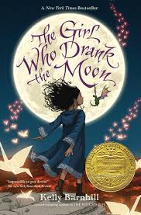
The Girl Who Drank the Moon
by Kelly Barnhill

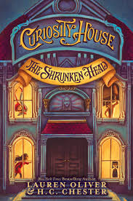
Curiosity House: The Shrunken Head
by Lauren Oliver

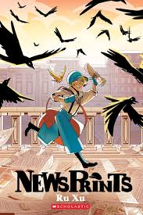
NewsPrints
by Ru Xu

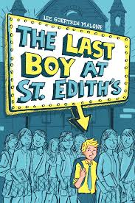
The Last Boy at St. Edith’s
by Lee Gjertsen Malone
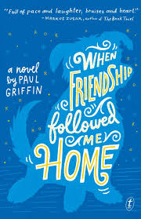
When Friendship Followed Me Home by Paul Griffin

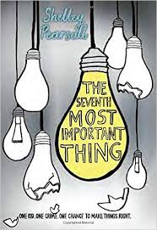
The Seventh Most Important Thing
by Shelley Pearsall

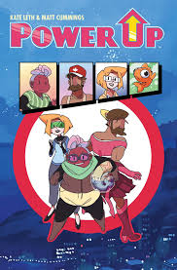
Power Up
by Kate Leth and Matt Cummings

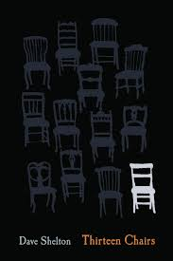
Thirteen Chairs
by Dave Shelton
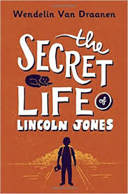
The Secret Life of Lincoln Jones by Wendelin Van Draanen

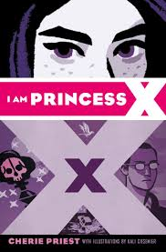
I am Princess X
by Cherie Priest

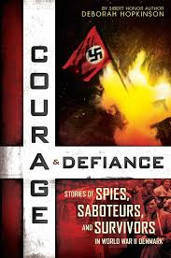
Courage & Defiance: Stories of Spies, Saboteurs, and Survivors in WWII Denmark by Deborah Hopkinson

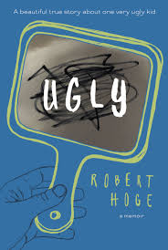
Ugly
by Robert Hoge

